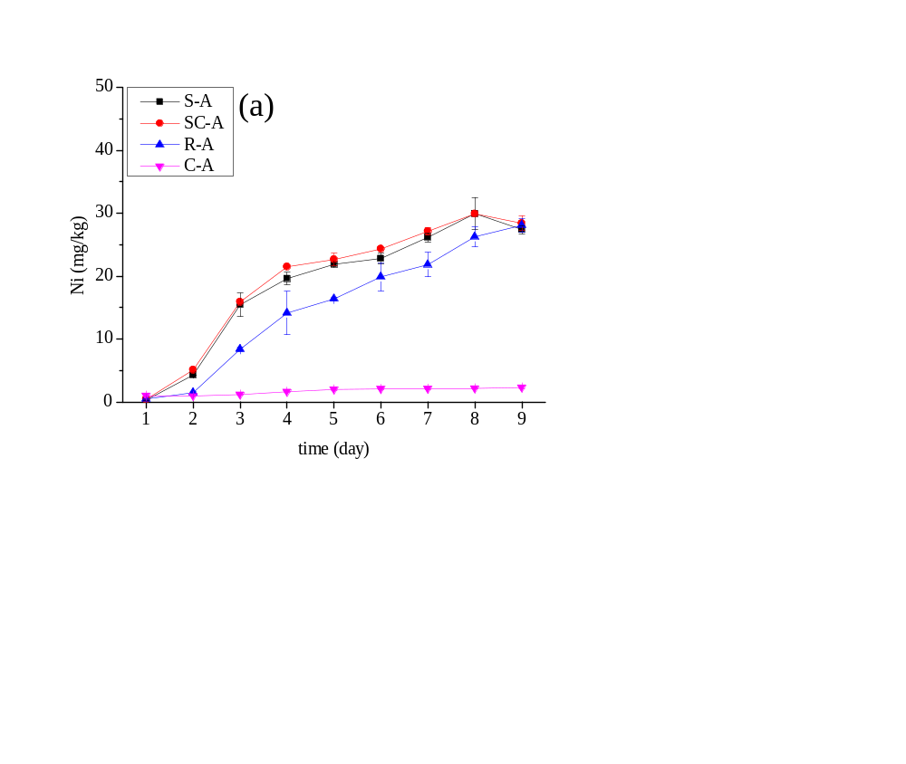
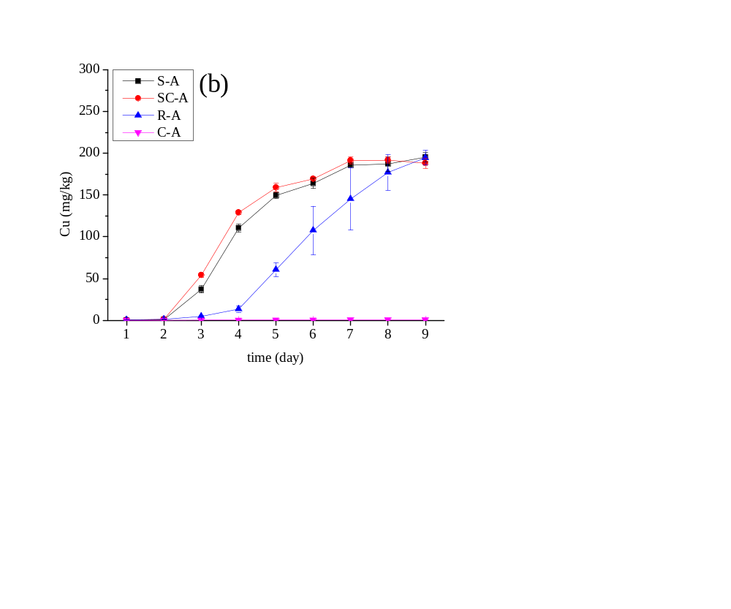
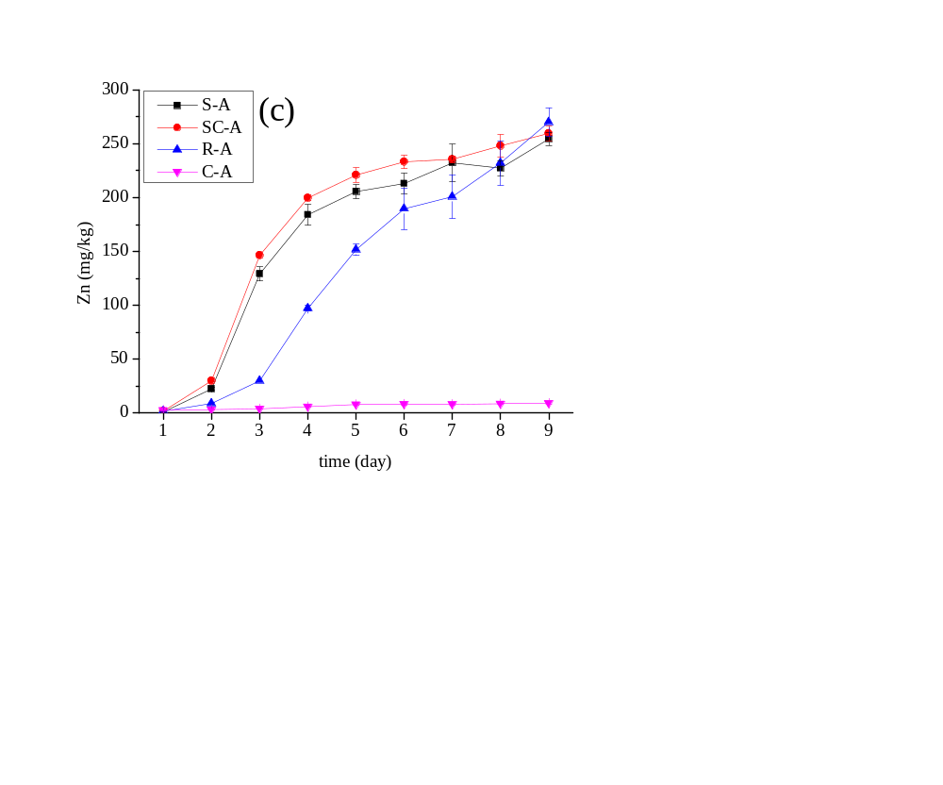
Fig. S1 Amount of heavy metal leached from the sediment during the bioleaching process. Fig 2 (a) (b) (c) represent the heavy metal bioleaching of Ni, Cu, and Zn, respectively, using different types of the sulfur substrate.

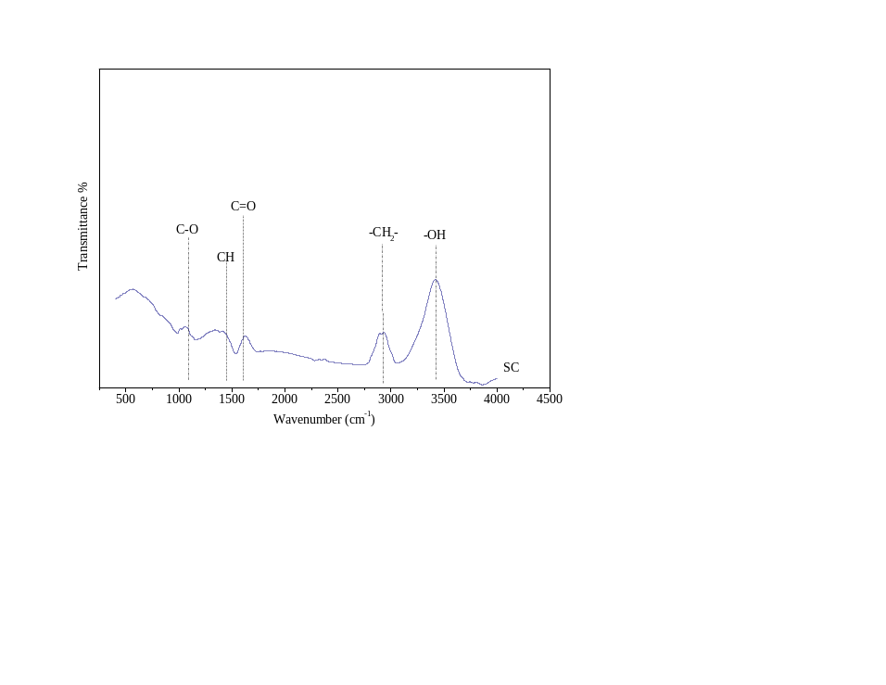
Fig.S2 Infrared spectrum analysis of bamboo biochar

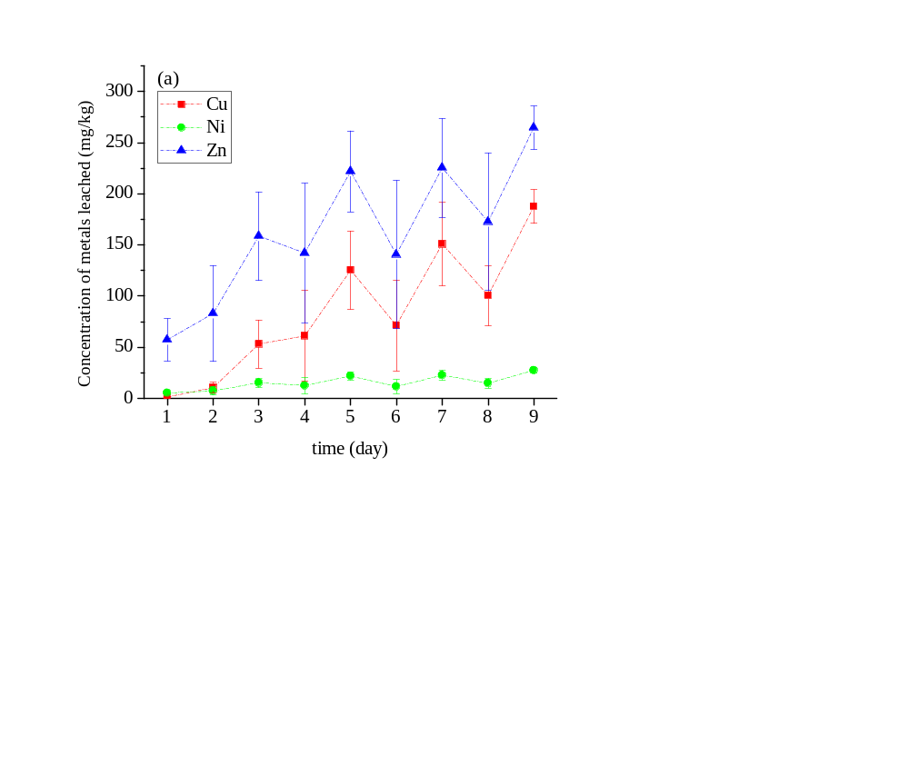
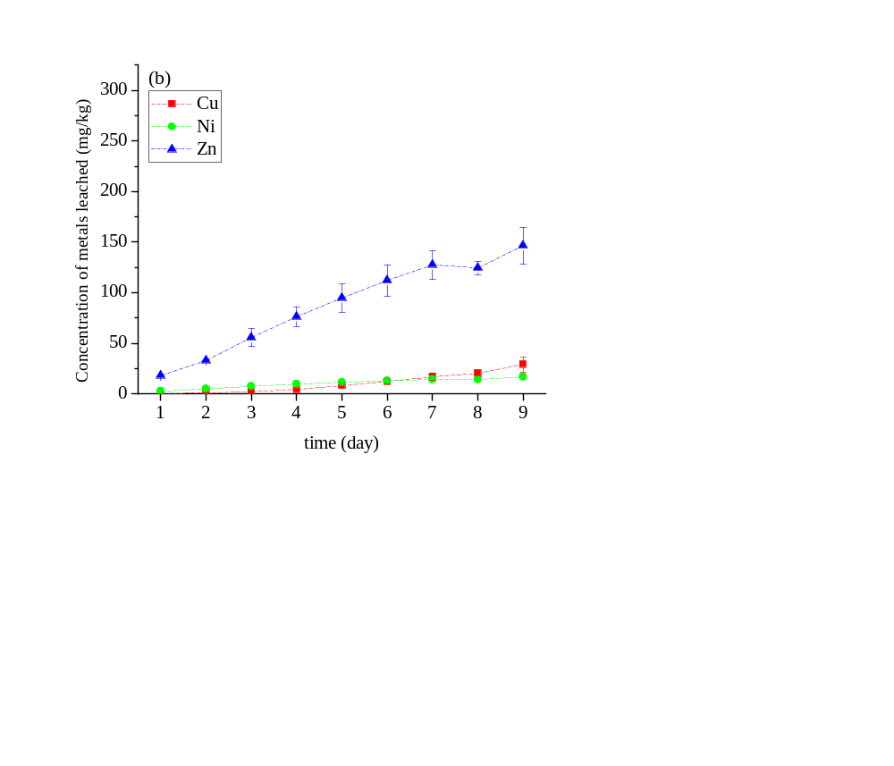

Fig. S3 Amount of heavy metal leached from the sediment during the second and the third round of bioleaching. Fig 2 (a) (b) represent the second and the third bioleaching round, respectively.

Analysis of heavy metal contents
The way to calculate the recoveries of heavy metal during the sequential extraction process As for sequential extraction procedure is as follows:
Five operationally defined states were divided: exchangeable state (S1), carbonate-bound state (S2), iron-manganese oxidation state (S3), organic state (S4) and residual state (S5).
The recoveries of HMs during the sequential extraction process can be calculated as follows:
Recovery(%)=(S1+S2+S3+S4+S5)/Total×100
where S1, S2, S3, S4 and S5 are the concentrations of each heavy metal in different states. Total is the total content of each heavy metal obtained by the digestion method. In this study, the recoveries of Ni, Cu and Zn were in the ranges of 79.08~117.92%, 76.16~107.94% and 74.93~113.62%, respectively. These results indicated that the sequential extraction procedure was reliable and precise enough for our study.

